China-Vietnam Relations over the South China Sea:
What’s Next after Trong’s Visit?
Li Jianwei and Ramses Amer

From 12 to 15 January 2017 General Secretary of Communist Party of Vietnam (CPV) Nguyen Phu Trong paid an official visit to China. During his stay in China, General Secretary of Communist Party of China (CPC) Xi Jinping and other four permanent members of CPC Political Bureau met Trong and his delegation. There is no doubt that the active interactions at the top leadership at the beginning of 2017 will positively contribute to the traditional bilateral friendship relations, in particular provide an opportunity for both countries to boost their mechanisms to handle the issues in the South China Sea (SCS), the most sensitive problem left in the bilateral relations.
As usual in the high-level meetings between China and Vietnam, the sea issues relating to the SCS were discussed during Trong’s visit, the result of which is highlighted in Point 6 of the Joint Communiqué. Both sides recognised that the SCS is the major outstanding problem existed in China-Vietnam relations and the issue is very complicated and vital, hugely affecting and governing the political trust, people’s sentiments, the direction of the two countries’ relations, as well as the regional situation. Due to the sensitivity of the issues involved and the difficulty to reach the final resolution, differences exist and at the current stage effective management is vital to prevent the issues from escalation.
Three basic components have again been emphasized in the most recent joint communiqué: principles, mechanism and functional cooperation. The principles in bilateral management include, first, peaceful settlement of disputes through negotiation and friendly consultation; second, to study and seek transitional solutions that do not affect the respective country’s stance and policy; and third, not to take actions that complicate and expand the differences. The bilateral principles are inked in the Agreement on Basic Principles Guiding the Settlement of Issues at Sea, signed between both countries in October 2011. Both sides agreed to follow the principles reflected in the United Nations Convention on the Law of the Sea and the Declaration on the Conduct of Parties in the South China Sea, to which both countries are signatories.
Bilateral mechanism has been established and adjusted through the years of mutual interactions over the SCS issues. Currently there are four layers of communication from the top to the functional level: High-level talks of leaders of Communist Parties, Governments and Congresses; Vice Prime Minister-level talks, e.g. the Steering Committee for Bilateral Cooperation; Ministry-level Talks, headed by the Ministries of Defense and Foreign Affairs; and Expert-level Talks, including various working groups. Working groups are established to implement agreements reached by the upper-level talks, either to further explore possibilities of functional cooperation or to give advice for agreed cooperation projects.
Functional cooperation is conducive to stabilising relations at difficult times and currently activities mainly focus on the sea areas within the Gulf of Tonkin (GOT) and off the mouth of the GOT. Within the GOT, besides the Joint Fishery Cooperation Committee to manage fishing in the Common Fishery Zone (CFZ), cooperation projects include, inter alia, joint navy patrol, joint patrol of law enforcement forces (coast guards of China and marine police of Vietnam), joint exploration for oil and gas in the agreed trans-boundary area and relevant cooperation matters in this regard, joint study on the management of maritime and island environment in the GOT. Letter of Intent on Marine Living Resources Enhancement was reached at the 9th meeting of the joint working group on less sensitive issues. Joint navy patrol in the GOT was initiated in 2006 and up till the end of 2016 twenty-one joint patrols have been organized. The purpose is to promote co-ordination on keeping good order at sea and in 2016 activities expand to include joint exercises on Search &Rescue. Joint patrol of law enforcement forces started in 2006 and by the end of 2016 twelve patrols have been carried out. 2016 was the first year that the two countries agreed to carry out two joint patrols in the CFZ. Joint field survey in the agreed area beyond the mouth of the GOT was completed in April 2016 after four months’ joint field work. Since 2013 three hotlines have been established, one between Fishery Administrations, one between Foreign Ministries and the third between Defence Ministries of both countries to promote communication over issues to both serious concern, including issues at sea.
Trong’s visit to China in early 2017 provides an opportunity for China and Vietnam to promote management in their SCS issues. Looking into the future, further efforts are needed in the following areas. First, continuously maintain high-ranking exchanges and meetings between leaders of the two Parties and countries to promptly exchange views and tackle issues arising in bilateral ties as well as make strategic orientations and directions to boost cooperation, maintain friendship and develop Vietnam-China ties in a healthy and stable fashion. High-level exchanges can take various forms including bilateral visits, special envoys, hotlines, annual meetings and meetings on the sidelines of multilateral forums, thus timely exchanging viewpoints on important issues in the relationship between the two Parties and countries as well as on regional and international situations, and defining orientations and directing the Vietnam-China ties’ growth in the new period. Second, promote and improve existing collaboration mechanisms between the two Parties and countries, especially meetings between representatives of the two Politburos, the Steering Committee for the Vietnam-China bilateral cooperation for strengthening the full implementation of bilateral agreements. Content at the expert-level talks could be expanded to include more functional cooperation topics to explore possible cooperation.
Third, take pragmatic thinking to expand and include all possible issues existed in bilateral South China Sea relations and take different policies and actions accordingly. There are roughly four areas under the China-Vietnam relations in the South China Sea, the GOT (Area 1), sea area off the mouth of the GOT (Area 2), Xisha Islands (Paracel Islands) and neighbouring sea area (Area 3), Nansha Islands (Spratly Islands) and surrounding sea area (Area 4) (See Illustration Map). Delimitation has been finished and cooperation goes on well in Area 1. Discussion and consultation on joint development and sea delimitation are ongoing in Area 2. Progress has been made in cooperation for developing joint development project. Both agree the existence of dispute in Area 4 and discussion on management of differences and cooperation on less sensitive areas have been ongoing in Areas 3 and 4, included in “sea-related issues”. Area 3 is the most sensitive area. Although fundamental differences exist and dispute cases happened more frequently here, the relevant problems have been excluded in bilateral discussion, which prevent a clear and effective management mechanism to be drawn in this regard. Both sides need to take pragmatic attitude to not only put Area 3 on the table, but also realize its deep sensitivity and create some no-action zone in managing the possible conflicts in this area. Fourth, promote and expand functional cooperation activities. Within Area 1 scientific research on marine resources has been carried out while sustainable management on marine living resources has been initiated, possibilities in this regard could be explored in Area 2 or 4. Based on existing cooperation activities in keeping good order at sea within Ares 1 and 2, possibilities could be explored to expand more activities such as joint exercises and mutual ship visits or to include Area 3 or Area 4 with necessary adjustments taking into consideration of the disputes exited.
Positive China-Vietnam relations in the SCS are conducive to not only overall bilateral relations but also to peace and stability in the SCS region. With creative thinking and continuous efforts from both sides a peaceful bilateral SCS relation can be realised.

Illustration Map of the Four Areas under China-Vietnam SCS Relations
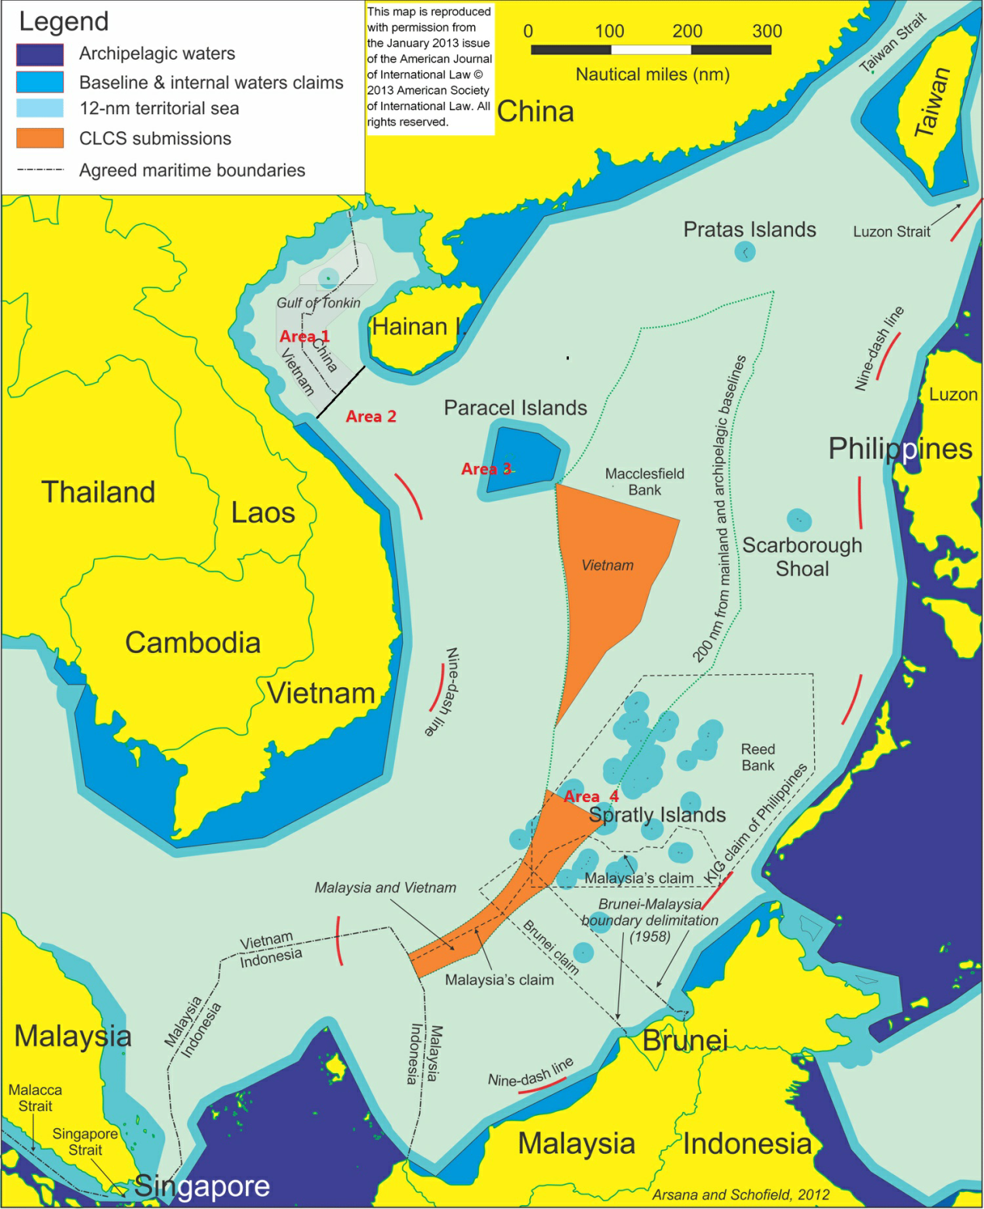
An area with clear boundary. Various cooperation projects ongoing well.

An area under consultation on joint development and delimitation. Joint field survey in the agreed area was completed. Possible future cooperation can extend to joint research and management on living resources.

Multilateral dispute area. Cooperation on less sensitive issues is to be explored either bilaterally or multilaterally.
Most sensitive area in China-Vietnam SCS relations. An effective mechanism is to be established on dispute management. Coordinated patrol and no-action zone arrangement are options to consider.

Source: The background map is from From Disputed Waters to Seas of Opportunity, NBR Special Report 30, July 2011, p.5.
Note: This map is drawn for the purpose of illustration of the location of Areas1-4. Beside Area 1, there is no definite borders for the other three areas.

Director and Research Fellow, National Institute for South China Sea Studies, China. Email: jw51cn@163.com, lijianwei@nanhai.org.cn.
Associate Professor in Peace and Conflict Research and Associated Fellow, Institute for Security & Development Policy, Sweden. Email: ramsesamer@gmail.com, ramses_a@163.com.

